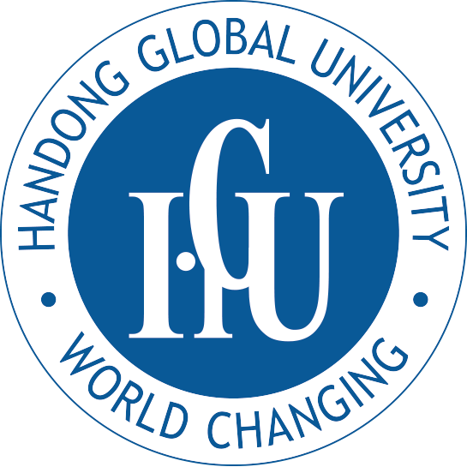 | Form 6 / Handong Cornerstone Scholarship Application  For Undergraduate Admission  HANDONG GLOBAL UNIVERSITY  Office of Admissions and HRD  Heunghae, Pohang, Gyungbuk 791-708, Republic of Korea

ATTENTION: Students from developing countries can apply for Handong Cornerstone Scholarship. Foreign students who are not from developing countries may not apply for the scholarship. Admissions officers will review all the documents and make the final decision. The information given below will be treated as confidential, and be seen only by admissions personnel at Handong Global University.

PERSONAL INFORMATION

Name |  | Phone Number
E-mail |  | Fax Number

Permanent Address

FAMILY FINANCIAL STATUS INFORMATION

Actual Income 2014 |  | Estimated Income 2015

Family Gross Earnings

(US＄)
(1) Current official exchange rate from your country’s currency to U.S. dollars: _______ = $1 US
(2) The primary source of family income: □ Salary / wages □ Family owned business / farm □ Other: __________

SELF DESCRIPTION

1. Explain why you are applying for Handong Cornerstone Scholarship. (e.g. financial status, academic excellence, etc.)

2. Explain how you will contribute to your country after graduation.

3-1. Write how you found out about Handong Global University and about Handong Cornerstone Scholarship

3-2. Write some things you know about the Republic of Korea.

